Supplementary Figure 2: Community engagement

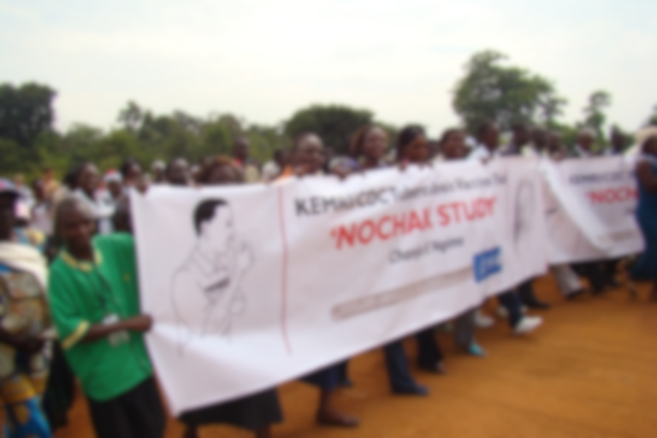

Supplementary Figure 3: Logistics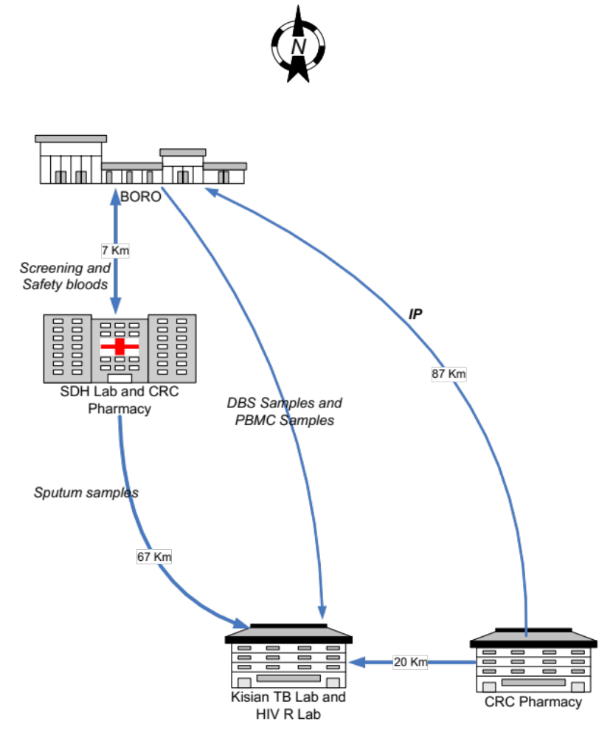

DBS: Dry Blood Spot
PBMC: Peripheral Blood Mononuclear Cells

Supplementary Figure 4: Siaya Clinical Research Annex
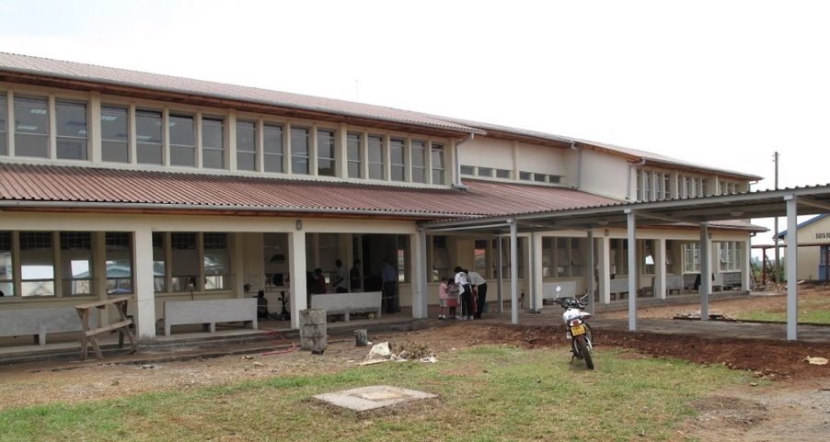

Supplementary Figure 5: Mobile Field Site

